Niagara Falls City School District

Health Services

Dear Parent(s) and Guardian(s):

We want to take this opportunity to remind you of important health requirements for the upcoming school year. Please review the information below and contact us if you have any questions.

* **Health Examinations (physicals):**
  + New York State law requires a health examination* for all new entrants and students in grades Pre-K or K, 1, 3, 5, 7, 9 & 11;
  + Every year for students in 7-12 grade participating in athletics (sports) *Must be completed by the District Nurse Practitioner/Medical Director Call 716-286-0788 for an appointment.*
  + For working papers as needed; or
  + When required by the Committee on Special Education (CSE) or Committee on Pre-School Special Education (CPSE).

***\*****A dental exam form is also requested at the same time a grade-level health examination is required*.

* **Immunizations (shots/vaccines):**
  + New York State law requires all students entering or attending (including remotely) any New York State school (public, nonpublic, and charter schools) must receive all doses of immunizations required for their grade level in order to attend school. The immunization requirements for each grade level are outlined on [NYSDOH Immunization Requirements for School Entrance/Attendance Chart*.*](https://www.health.ny.gov/prevention/immunization/schools/#ln3)Students who do not have the required immunizations may not attend school*.*
  + A request for medical exemption to immunization must be completed on this form: [Medical Exemption Statement for Children 0-18 Years of Age (ny.gov).](https://www.health.ny.gov/forms/doh-5077.pdf)
* **Prescribed & Over-The-Counter Medications**

If your child needs to take medications during the school day the school must have the following:

* + - A written healthcare provider order, (Attestation is also required for independent students)
    - Written parent/guardian consent, ***See page 3 section B in this packet***.
    - The medication must be brought to the school by an adult. The medications must be in their original labeled prescription or over-the-counter bottles/packaging. Any special supplies or equipment for the nurse to administer the medication must also be provided to the school.

**Attached is the *New York State Required Health Examination Form* you must give to the healthcare provider doing the health examination. You will also find a copy of the Health history, Dental Certificate but the *NYSDOH Immunization Requirements for School Entrance/Attendance Chart is not published as of this mailing please notify your child’s school nurse for a copy.*** If you have any questions please reach out to your school nurse at your child’s school. Sincerely,

Sincerely,

Dr. Philip Savageau M.D.

Medical Director F16 04/24

# New York State Immunization Requirements for School Entrance/Attendance

Children attending day care and pre-K through 12thgrade in New York State must receive all required doses of vaccines on the recommended schedule in order to attend or remain in school. This is true unless they have a valid medical exemption to immunization. This includes all public, private, and religious schools. A medical exemption is allowed when a child has a medical condition that prevents them from receiving a vaccine. There are no nonmedical exemptions to school vaccine requirements in NYS.

The CDC's Advisory Committee on Immunization Practices (ACIP) establishes the recommended vaccine schedule and determines when vaccines are due.

# Important school immunization information

Within 14 days of the first day of school or day care, parents must:

* Show proof of their child's up-to-date vaccinations, OR
* Provide a valid medical exemption from vaccination.

In order to attend or remain in school or day care, children who are unvaccinated or overdue must receive at least the first dose of all required vaccines within the first 14 days. They also must receive subsequent vaccines in the series within a 14-day period of when they are due to complete the immunization series.

# Vaccines required for day care, pre-K, and school attendance

* Diphtheria and Tetanus toxoid-containing vaccine and Pertussis vaccine (DTaP or Tdap) • Hepatitis B vaccine
* Measles, Mumps and Rubella vaccine (MMR)
* Polio vaccine
* Varicella (Chickenpox) vaccine

## Additional vaccines required for middle school and high school

* Tdap vaccine for Grades 6-12
* Meningococcal conjugate vaccine (MenACWY) for Grades 7-12
* Students in Grade 12 need an additional booster dose of MenACWY on or after their 16th birthday

## Additional vaccines required for day care and pre-K

* Haemophilus influenzae type b conjugate vaccine (HiB)
* Pneumococcal Conjugate vaccine (PCV)

## IMPORTANT THINGS TO REMEMBER

1. The Niagara County Health Department provides immunizations by appointment only. Please Call 278-1903 for an appointment.
2. Parents must show proof of the required Immunizations within the first 14 days of attendance in school or within the first 30 days if transferring from a school district outside of NYS.

Niagara Falls City School District

Health Services

Student’s Name _____________________________________ Date of Birth________________ Gender at birth M____ F_____

Mothers Name_______________________________ Address_________________________________ Phone______________

Mothers Place of Employment_______________________________________________ Work Phone________________

Fathers Name________________________________ Address__________________________________ Phone______________

Fathers Place of Employment________________________________________________ Work Phone________________

Emergency: 1. Name___________________________________ Phone______________________________

2. Name___________________________________ Phone ______________________________

Describe your child’s current state of health (circle one): Excellent Good Fair Poor

|  |  |  |  |
| --- | --- | --- | --- |
| **A. Has your child ever:** | **YES** | **NO** | **If Yes, please explain and include date:** |
| Had an ongoing medical condition | ◻ | ◻ |  |
| Seen a medical specialist | ◻ | ◻ |  |
| Had allergies: | ◻ | ◻ | ◻food ◻environmental ◻insect ◻medication  ◻other |
| Been hospitalized | ◻ | ◻ |  |
| Had an operation | ◻ | ◻ |  |
| Had an injury requiring an Emergency Room visit | ◻ | ◻ |  |
| Missed 5 days of school in a row due to illness/injury | ◻ | ◻ |  |
| Had a bone/muscle injury | ◻ | ◻ |  |
| Passed out, had a concussion or serious head injury | ◻ | ◻ |  |
| Had a convulsion/seizure | ◻ | ◻ |  |
| Had a vision problem or condition | ◻ | ◻ | ◻ glasses ◻ contacts |
| Had a hearing problem or condition | ◻ | ◻ | ◻ hearing aid ◻ cochlear implant |
| Worn dental bridge, braces or mouthpiece | ◻ | ◻ |  |
| **Have any family members under the age of 50 ever**: | **YES** | **NO** | **If Yes, please specify:** |
| Had a heart attack | ◻ | ◻ |  |
| Had other serious health problems | ◻ | ◻ |  |

**CHECK ALL THAT APPLY TO YOUR CHILD:**

|  |  |  |
| --- | --- | --- |
| * ADHD * Asthma/trouble breathing * Autism/Asperger * Dental Injuries * Diabetes * Ear Infections | GI Conditions (ulcer, reflux, IBS)   * Headaches/migraines * Heart Conditions * High Blood Pressure * Mental Health Condition   (depression, eating disorder, anxiety, OCD, ODD, etc.) | * Scoliosis * Single Organ (◻kidney, ◻testicle) * Skin Condition * Speech Condition * Urinary Condition   Females Age Menstruation began ______  Date of last menstrual period _______ |

Are there any condition that would prevent your child from participating in physical education or sports? ◻ No ◻ Yes

All medications have side effects and for your child’s safety, it is important for the School Nurse to have this information.

PLEASE LIST ALL MEDICATIONS YOUR CHILD TAKES AT HOME ONLY: *_______________________________________________________________________________________________________*

*_______________________________________________________________________________________________________*

**PLEASE BE SURE TO COMPLETE BOTH SIDES OF THIS FORM**

HAS YOUR SON/DAUGHTER:

Ever been a patient in a hospital? Yes ___ No ___ If yes, Date __________ explain _____________________________

Had any operations? Yes ___ No ___ If yes Date __________ explain __________________________________

Had any accidents? Yes ___ No ___ If yes Date __________ explain __________________________________

Is your son/daughter under a physician’s care now? Yes ___ No ___ explain __________________________________

Is he/she allergic to any medication? Yes ___ No ___ explain______________________

Has he/she participated in any psychological testing? Yes ___ No ___ If yes Date _______________________

PLEASE ADD ANY ADDITIONAL PERTINENT FAMILY MEDICAL HISTORY: ____________________________________________________

________________________________________________________________________________________________________________

PLEASE LIST ANY ADDITIONAL CONCERNS: ___________________________________________________________________________

_________________________________________________________________________________________________________________

(ATTACH AN ADDITIONAL SHEET IF NECESSARY)

Parent/Guardian Signature **REQUIRED**___________________________________________ Date ________________



***B. PLEASE LIST & SIGN FOR ALL MEDICATIONS YOUR CHILD WILL NEED AT SCHOOL.***

MEDICATION DOSE TIMES

_______________________________________________________________________________________________________

_______________________________________________________________________________________________________

_______________________________________________________________________________________________________

I request that my child receive the medication as prescribed by our health care provider. THE NEW YORK STATE EDUCATION

DEPARTMENT REQUIRES THAT ALL MEDICATION IS TO BE FURNISHED BY ME IN A PROPERLY LABELED ORIGINAL CONTAINER

FROM THE PHARMACY AND MUST BE BROUGHT TO THE SCHOOL HEALTH OFFICE BY A PARENT OR GUARDIAN.

It is the policy of the School District of the City of Niagara Falls that these procedures must be followed or the school will not be responsible for the administration of the medication. I understand that the school nurse, will administer the medication.

I agree if my child’s health care provided allows HIM/HER to self-carry the approved medication.

Yes ______ No _______ Parent Initials _________

**If yes please see section C *for the nurse to obtain the medical orders for the above medication.* If no *medication at school skip this signature***

Signature (Parent or Guardian) _______________________________________ Date_________________



**AUTHORIZATION FOR USE OR DISCLOSURE OF PROTECTED HEALTH INFORMATION**

**C. *This section/signature is optional:***

**In order to share protected health information with the school district, your healthcare provider may require the completion of the statement below to comply with the requirements of the Health Insurance Portability and Accountability Act (HIPAA). Please complete and sign the information below to avoid delays in care for your child.**

I, __________________________________________ authorize my child’s healthcare provider(s) listed below to release

(Print name of parent/guardian)

My child’s _____________________________ medical records to the district’s medical inspector or school nurse.

(Child’s Name)

Health Care Providers Name _________________________________________ Phone _______________________

Health Care Providers Name _________________________________________ Phone _______________________

Health Care Providers Name _________________________________________ Phone _______________________

The healthcare provider may disclose the following protected health information: (Check all that apply)

 Immunizations

 Health Appraisals (Physical Exam)

 Current Medications listed in section B above

 Other_________________________________________________________________

Signature (Parent or Guardian) _______________________________________ Date_________________

**PLEASE BE SURE TO COMPLETE BOTH SIDES OF THIS FORM**

This sample resource

is located a

[t](http://www.schoolhealthny.com/)

[www.schoolhealthny.co](http://www.schoolhealthny.com/)

[m](http://www.schoolhealthny.com/)

–

Samples|Forms|Notifications

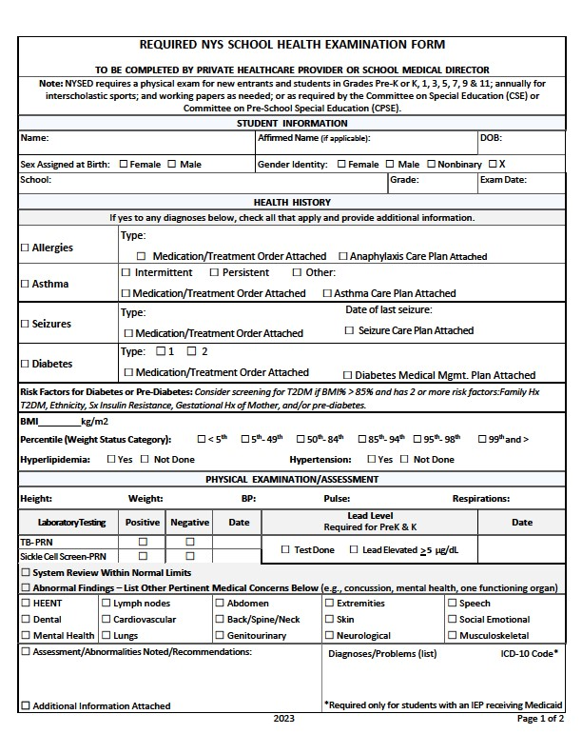

is located a

[t](http://www.schoolhealthny.com/)

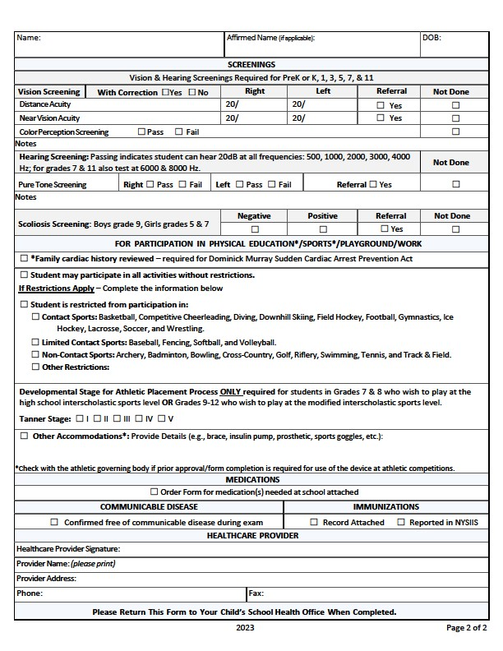

Niagara Falls City School District

Health Services

